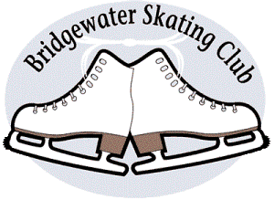

**A. SETTING UP FAMILY ACCOUNT IN UPLIFTER**

  1. Access the **LOGIN** button in the upper right hand corner.

  2. Create your **FAMILY ACCOUNT** login information (***please remember your “password” for******future use****)*

1. Must be in name of Parent/Guardian
2. All boxes with RED * must be filled in
3. Check box "I will be registering myself into programs” ONLY if YOU intend on skating on a session.
4. Add Current HOME Address
5. Message List – mark boxes for messages you want to receive.
6. When completed all boxes – click “continue”

  3. Click on **MY ACCOUNT** (top right side of page)

* Click on “Participants”
  + Add “new skater”
  + Fill in details
  + ADD SKATER'S SKATE CANADA NUMBER (if returning member)
  + Click “add skater”

   NOTE: Do Not check box beside “I would like to register myself into programs” if you are a parent registering a child. Only check the box if you are an adult skater registering yourself for a program.

* Do this for every participant skater you want to add, (if you have more than one child skating)

**B. REGISTER FOR ALL PROGRAMS**

1. Go to **REGISTRATION** in the Menu Bar
   * Select the desired skating level registration
   * You will be able to select the “program” you wish to register for & click Register
   * Select the “skater” for the program.
2. **CONFIRM** Registration
   * You have 30 minutes to complete your transaction
   * NOTE: if 30 minutes of inactivity it will clear your shopping cart.
3. Read and **ACCEPT/REJECT**
   * Club “policies” that pertain to the program you are registering for.
   * BSC protocol, and Skate Canada Waiver must be accepted to continue.
   * Photo/Social Media policy must be accepted first however may be rejected by selecting it again.
4. Proceed to **CHECKOUT**
   * No cash or cheque payment will be accepted for registration
   * A confirmation invoice will be emailed to you
   * Pay invoice via e-transfer, please include skaters name and invoice number in the comments.